**Payless CAR Rental**

TeamID: **15**

Name: **Aishwarya Ram Solaisamy Ramachandran**

Instructor: Hanh Pham

Database Name: b_f19_15_db

CS Location to Test:<https://cs.newpaltz.edu/e/b-f19-15/>

**Table Of Contents:**

1. Title
2. Table of Contents
3. Business Model

3.1. Business Requirements

3.2. Technical Requirements

1. Design

4.1. Architecture

4.2. Protocols

4.3. Data Examples

1. Implementation
2. Demo/Test
3. Developer’s Guide
4. Challenges
5. Conclusion
6. Reference/Appendixes

**3. BUSINESS MODEL**

**3.1. Business Requirements**

Payless Car Rentals is an e-commerce website designed for E-city citizens to provide Car Rental service. Our Products includes the following Categories with the Product Quantity by the side.

1. **Car**

**1.a. Standard Car** - A total of 2 Varieties in Standard Car.

Dodge Grand Caravan

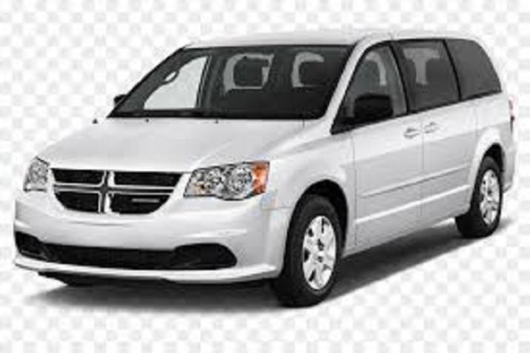

VW Jetta



1. **b. Full Size Car -** A total of 1 Variety in Full Size Car

Ford Fusion



**2. SUV**

**2.a. Compact SUV** - A total of 1 Variety in Compact SUV

Dodge Durango



**2.b. Full Size SUV** - A total of 1 Variety in Full Size SUV

Ford Expedition



**3. Van**

**3.a. Mini Van** – A total of 1 Variety in Van

Mazda 5



Each of the above Vehicles have stock of 100 numbers in the inventory. Every time an order is placed, the inventory count will be updated based on the request. We can track the Item In count and Item Out count in the Products Table in the Database.

**Business Model:** B2C, B2B

**Business Context and Goals:**

Payless Website has:

* Registration Page Form for new users
* Login Page for existing users
* Home Page that contains a Header and Footer with Navigation Links to the other Web Pages in the Rental Website. The Product Catalog display on the Home Page.
* A Shop Page where the user can view all the Vehicles from the inventory and view the Product details. The Product Catalog is displayed dynamically from the Database. Product Details Page where the user can choose the number of days to rent the vehicle, Model of the car and add them to Cart.
* A Shopping Cart Page where the user can view the items in Cart , the total cost and edit the items when needed. For Ex. Delete some of the items and adding new items to the Cart.
* A Check Out Page which has the Order Summary with shipping costs included, Shipping Details and Payments Details. On click of the “Confirm Payment" button, the order will be placed and the user will be given his Confirmation Number.

**Our Customers:**

Payless Car Rental primarily serves E-City Citizens who

1. Require a temporary vehicle for example, those who do not own car,

2. Travelers who are out of town, or

3. Owners of damaged or destroyed vehicles who are awaiting repair or insurance compensation.

**How I sell my product?**

I provide rental car services via website.

**PLATFORM:**

Payless Rental supports the following

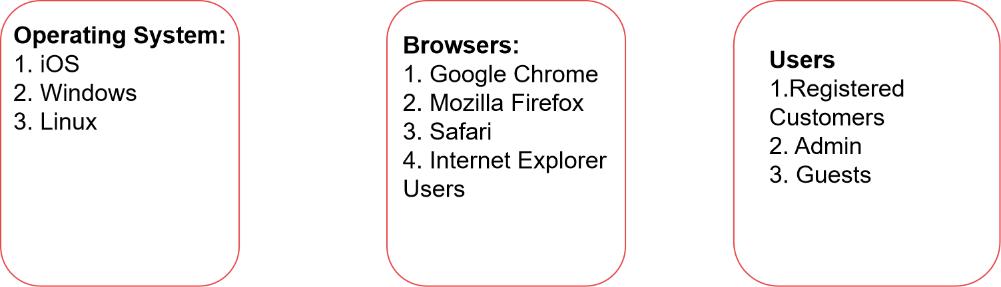

**3.2. Technical Requirements**

Programming Languages Used:

a) Client Side Programming Language: HTML 5, CSS3 Bootstrap, Javascript

b) Server Side Programming Language (Middleware/Framework): PHP

c) Back end Programming: SQL Queries in PHP MyAdmin

Web Server Used: CS Web Space

SQL Server: Database Name: b_f19_15_db

**4. DESIGN:**

**4.a. ARCHITECTURE**

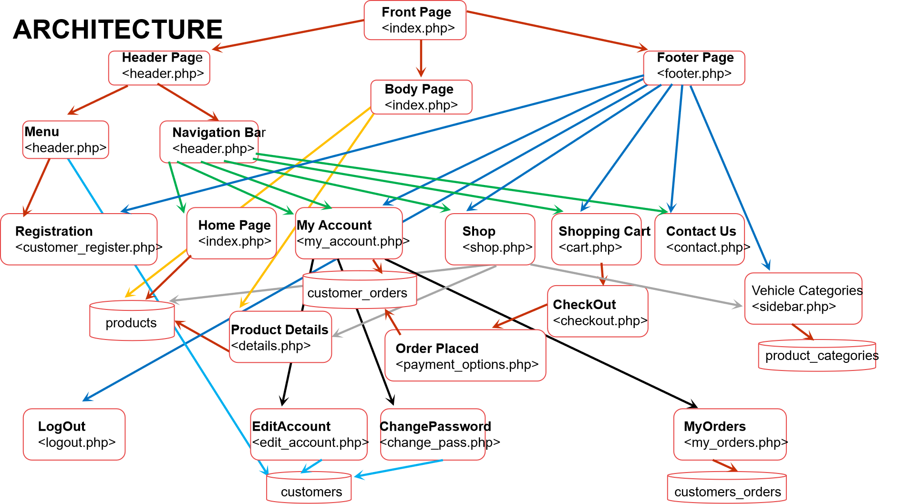

**4.b. Protocols: Transaction**

T1: REGISTRATION - Enables a new customer to register his information

T2: LOGIN - Enables an existing customer to login

T3: SHOP PAGE - Displays all the vehicle information to the Guest, Registered Users dynamically from the database.

T4: DETAILS PAGE - Displays details about the vehicle like Model, No.of Days to hire, etc.

T5: PAYMENT OPTIONS PAGE – Gets the Shipping and Payment information from the User and stores the order information in the customer_orders table.

T6: MY ACCOUNT - MY ORDERS - Displays the order information of a registered customer like Amount, Invoice Number, No.ofDays, Order Date, Paid/UnPaid and Status.

T7: MY ACCOUNT - EDIT ACCOUNT - Enables the customers to edit their account information

T8: MY ACCOUNT - CHANGE PASSWORD - Enables the customers to change their passwords

**T1: REGISTRATION**

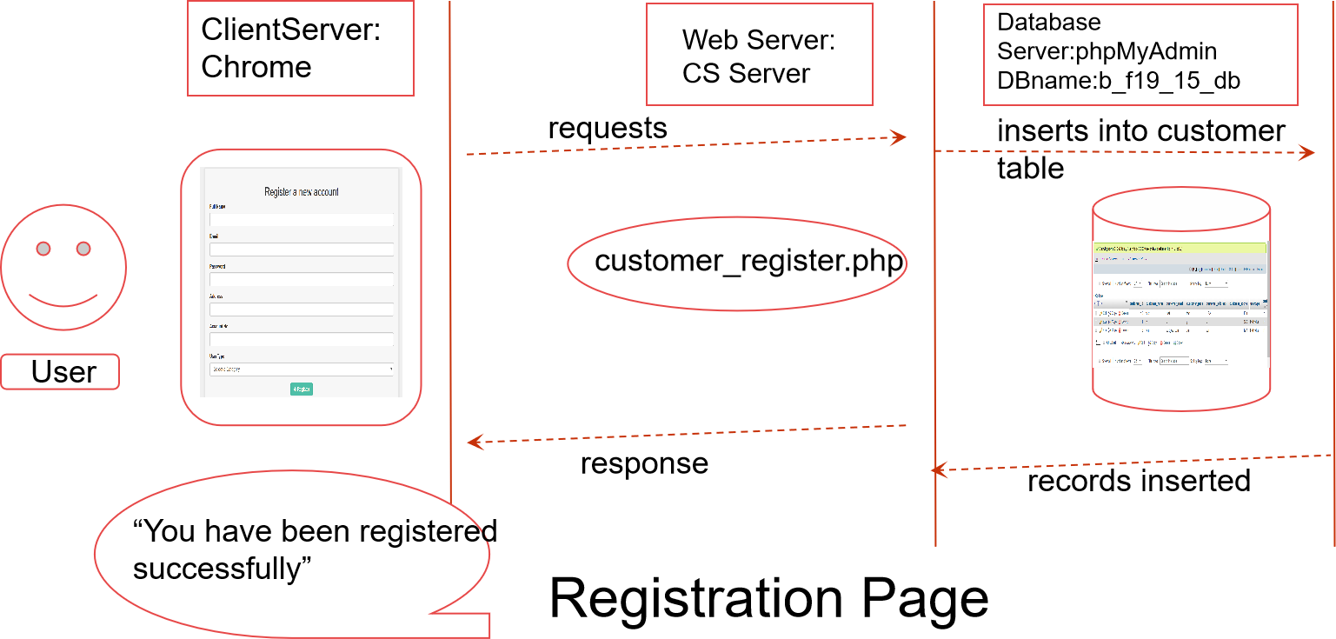

**T2: LOGIN**

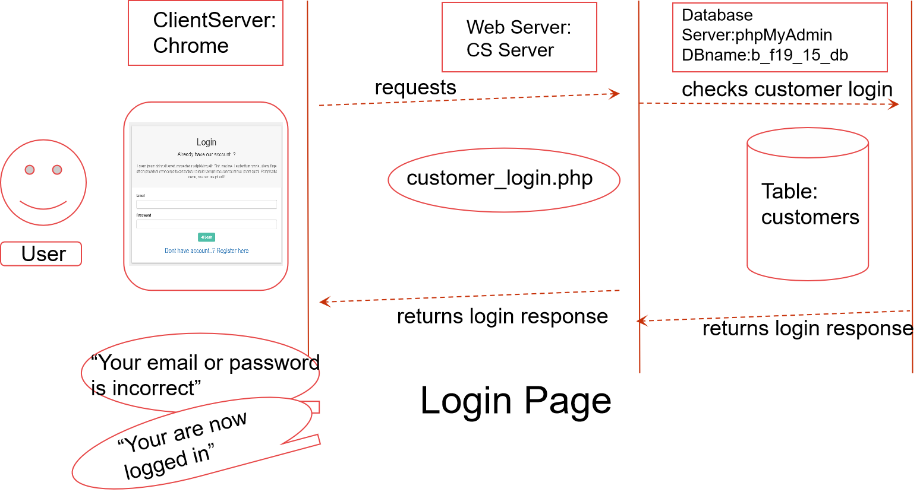

**T3: SHOP PAGE**

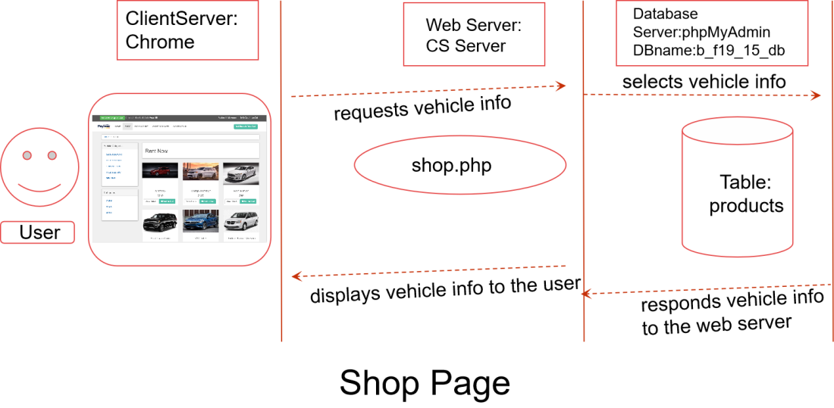

**T4: DETAILS PAGE**

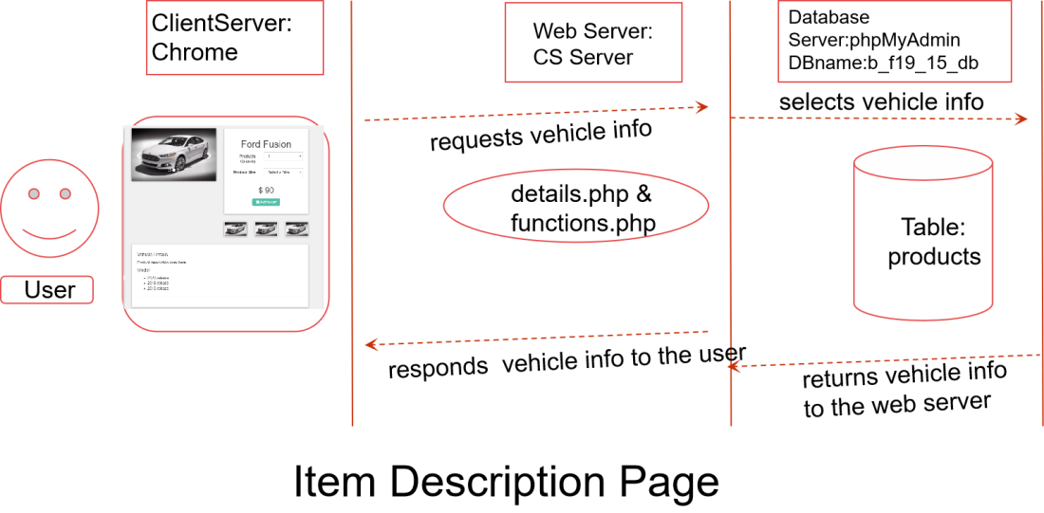

**T5: PAYMENT OPTIONS PAGE**

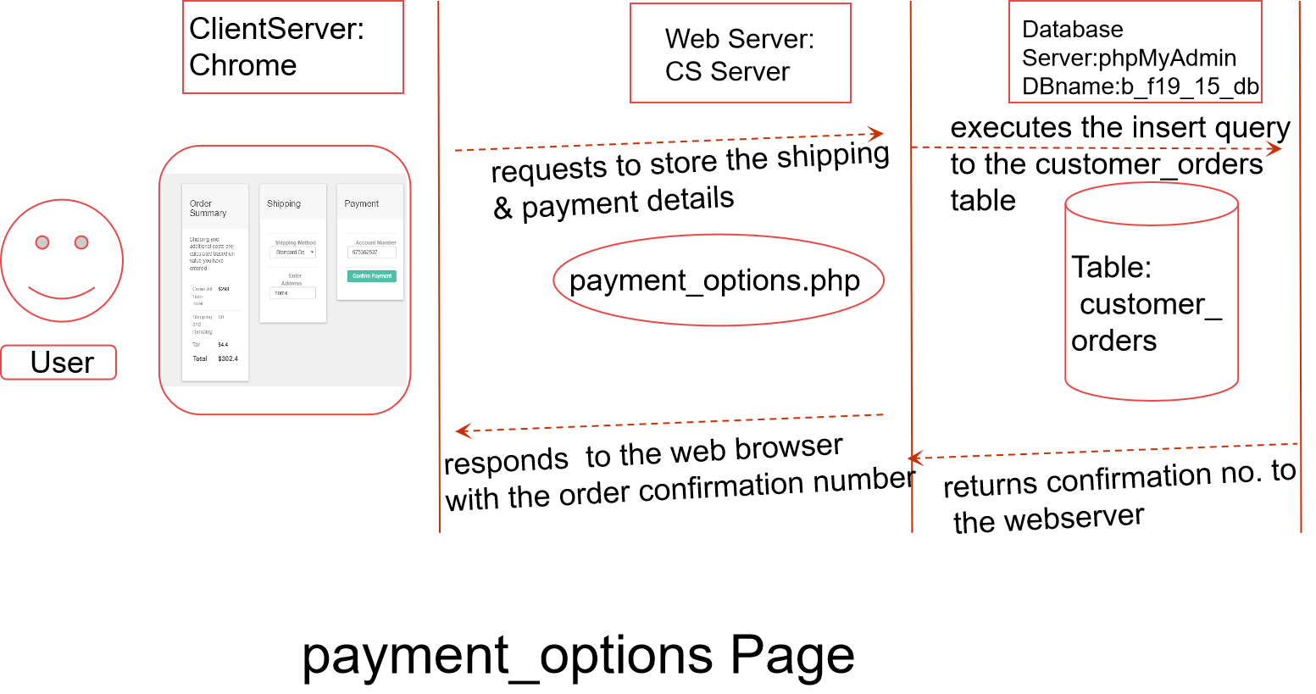

**T6. MYACCOUNT- MYORDERS PAGE**

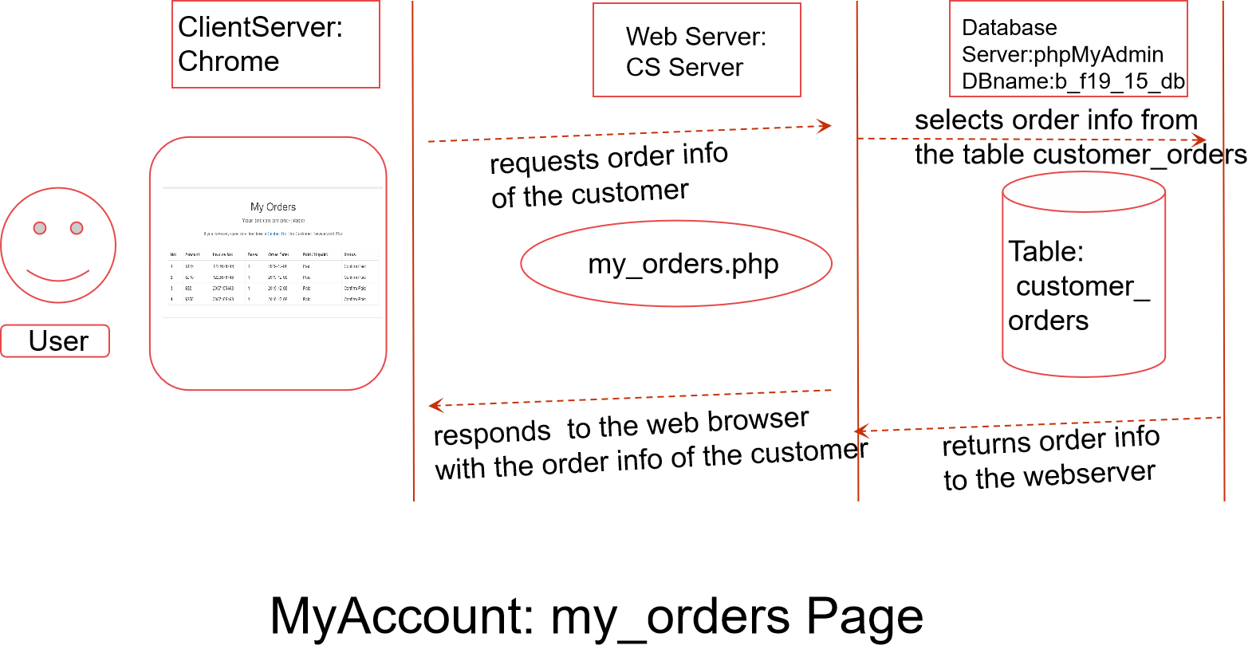

**T7: MYACCOUNT- EDIT ACCOUNT PAGE**

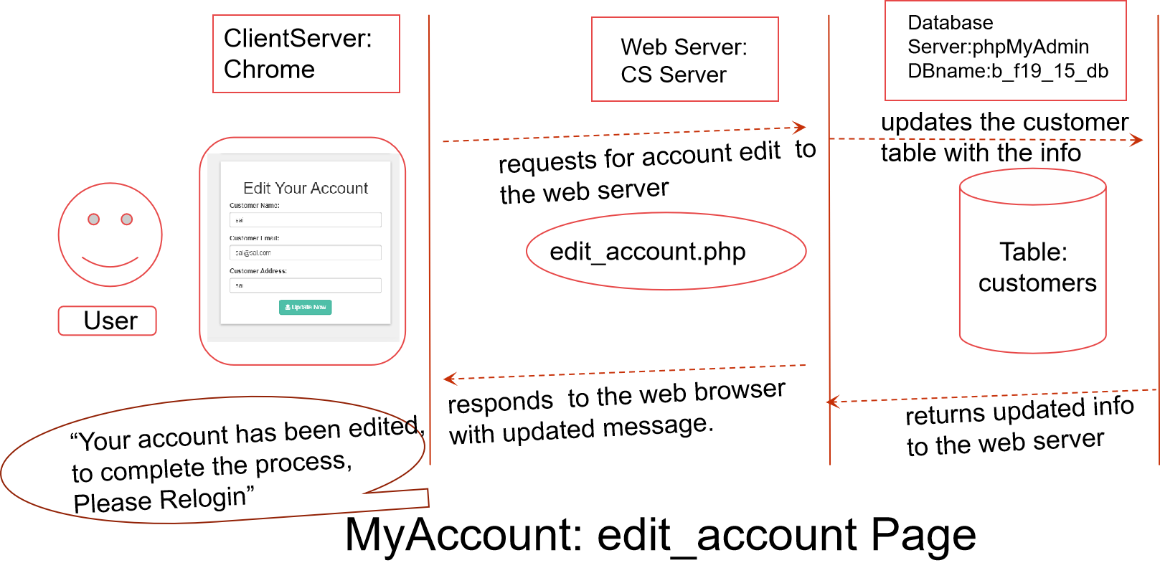

**T8: MY ACCOUNT – CHANGE PASSWORD PAGE**

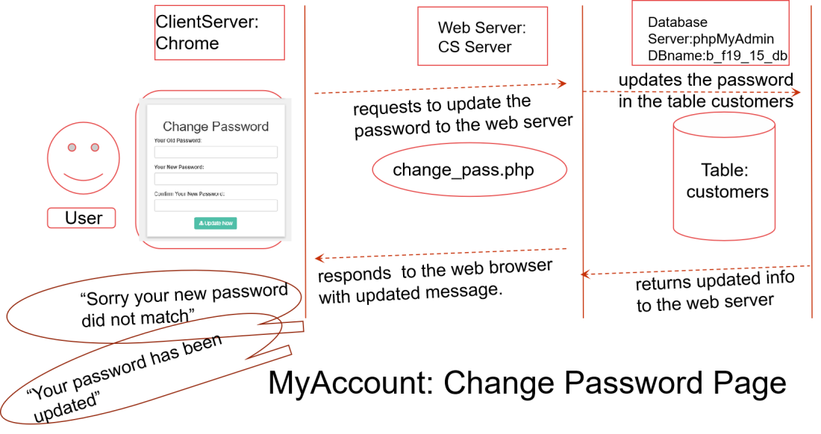

**5. IMPLEMENTATION:**

This is hand coded website developed from scratch, I have spent about 3.5 months working on this Project. I have used small pieces of code from GeeksforGeeks for login and registration to get started with. I have also referred the Nature’s Resource Project which Professor has shared with us on her website. I got some idea after going through the structure of the project and what is expected from me. On the whole, I was able to learn new things while developing each page. The websites I referred to, is mentioned in the last slide.

**Web Site Address:**

<http://cs.newpaltz.edu/e/b-f19-15/>

All the files and folders under /var/www/ebusiness/b-f19-15/html/ have permission of chmod 755

The e-city customer will see the below Home Page when he goes to my website link for team15.

<https://cs.newpaltz.edu/e/b-f19-15/index.php>

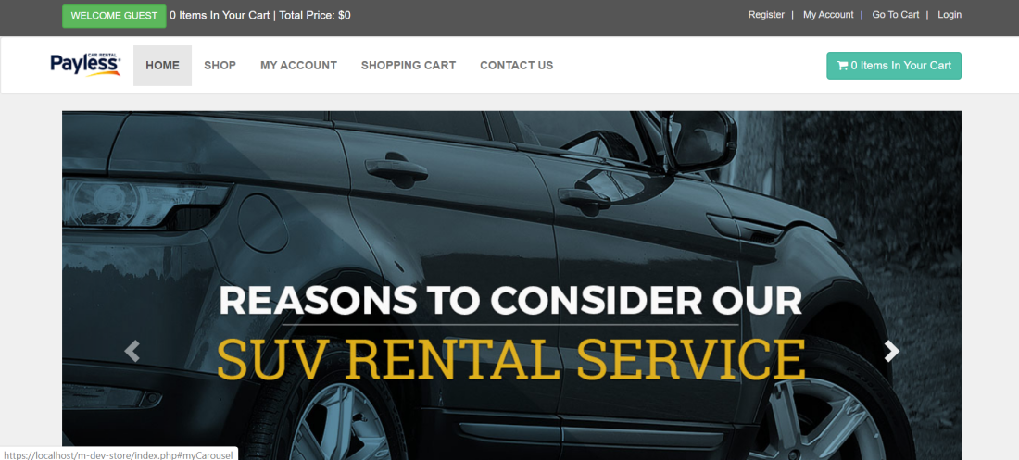

Fig 5.1 Home Page

**Map of all the Sub Directories:**

/var/www/ebusiness/b-f19-15/html/ - All the folders and files are located under this sub directory. See below for clear understanding.

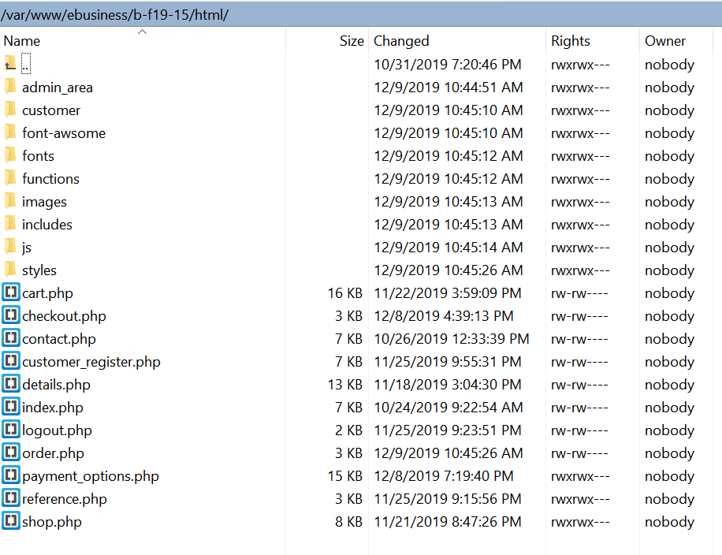

Functions like add_cart, get_productdetails, get_prodcategories, items, total_price calculations are done under functions.php under functions folder.

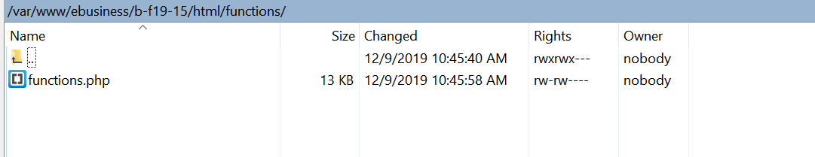

Include folder has header.php, footer.php, db.php(contains the connection string for the connection to database) and sidebar.php (that contains the vehicle categories as Cars, SUVs and Vans in the Shop and PaymentOptions Page)

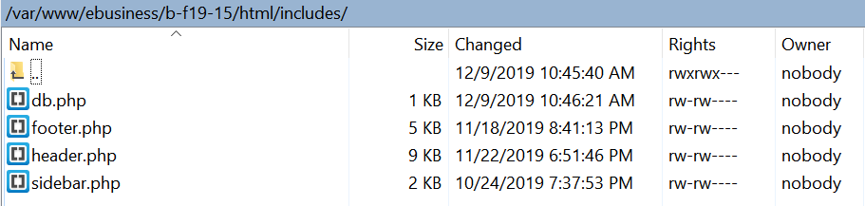

Customer folder under /var/www/ebusiness/b-f19-15/html/customer/ has its own “functions” folder, “includes” folder and other pages specific to the registered user.

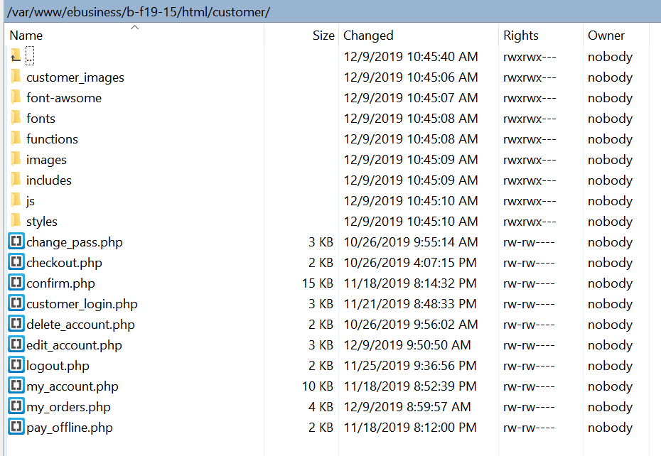

The Home Page has the following

**5.1.a Header** – Header has Navigation Links to the below:

**Header:** Code can be found from header.php

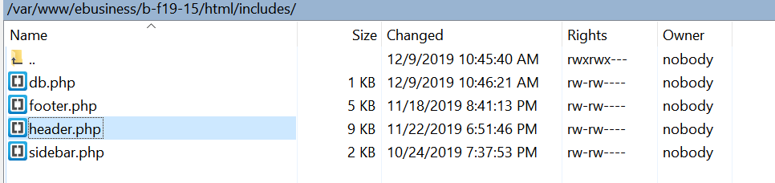

Registration Page Website Link: <https://cs.newpaltz.edu/e/b-f19-15/customer_register.php>

**PHP Code:**

customer_register.php

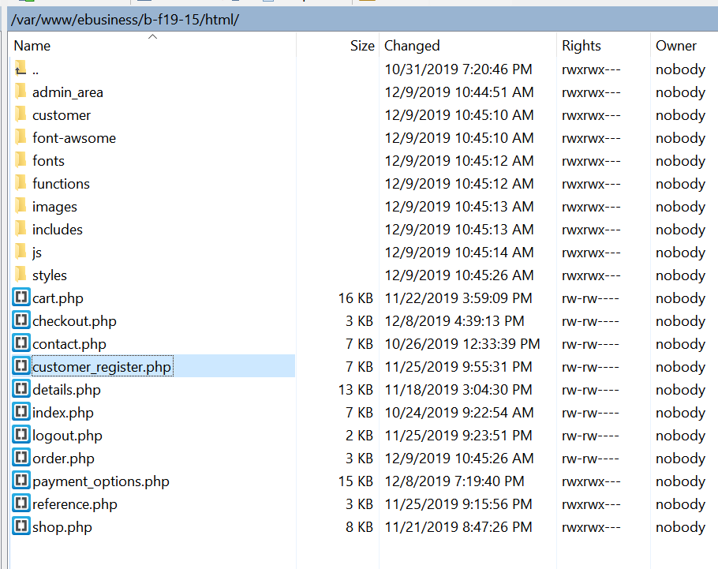

Registration Page looks like the one below in User Interface (UI).

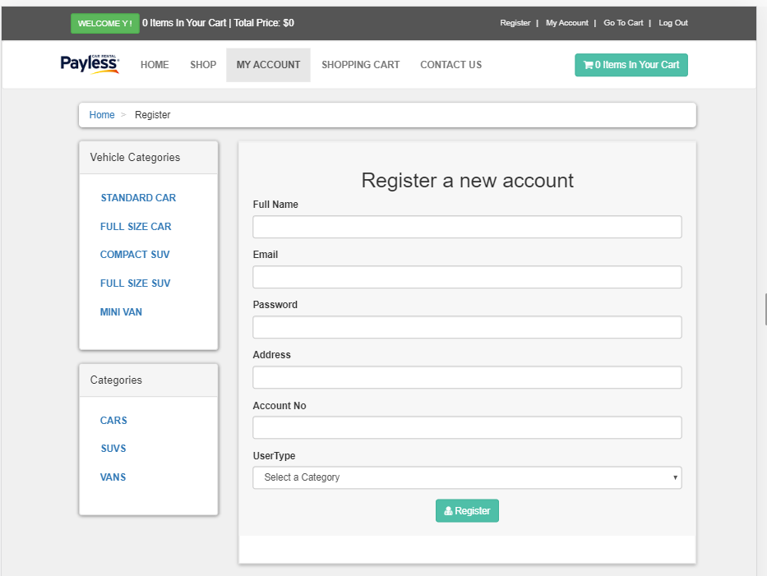

**My Account Page:**

If the user has not logged in, it redirects to <https://cs.newpaltz.edu/e/b-f19-15/checkout.php> which is a login page.

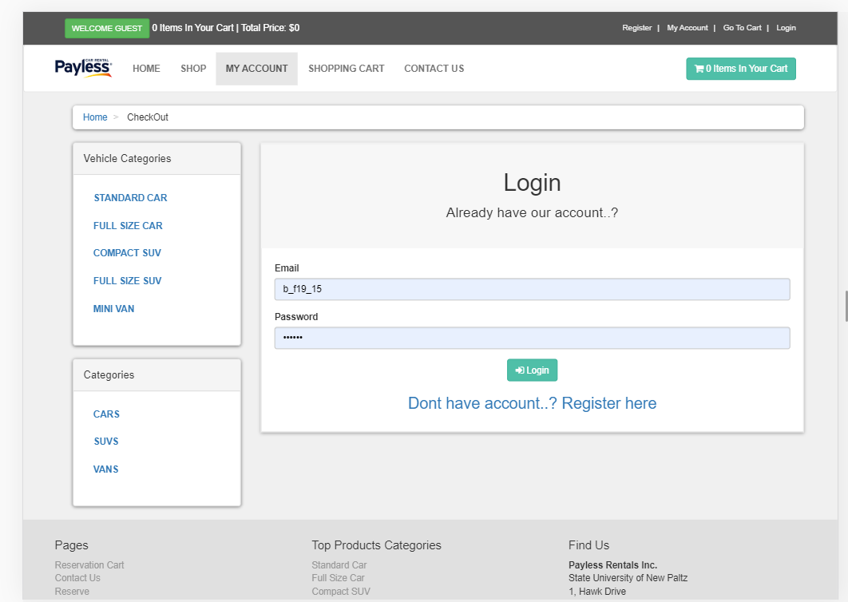

PHP Code can be found from here: customer_login.php under “customer” folder.

See the image below for the directory location.

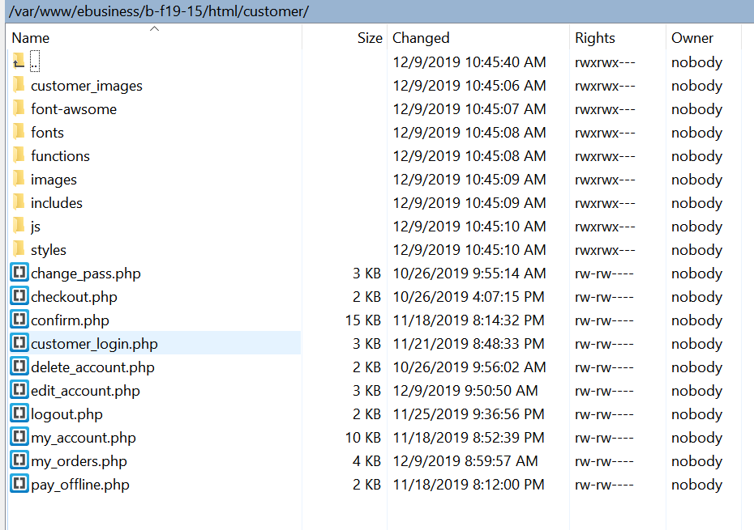

If the user has already logged in, it redirects to the Order Details Page which has details about the orders placed previously or it is empty if there is no order placed.

<https://cs.newpaltz.edu/e/b-f19-15/customer/my_account.php?my_orders>

PHP Code can be found from here: my_orders.php under “customer” folder.

See the image below for the directory location.

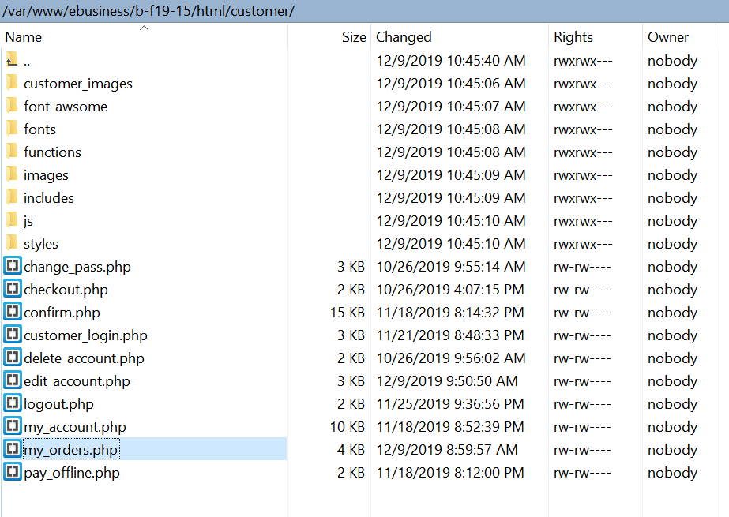

If there are previous history of orders placed by the user, then the page looks like the one below.

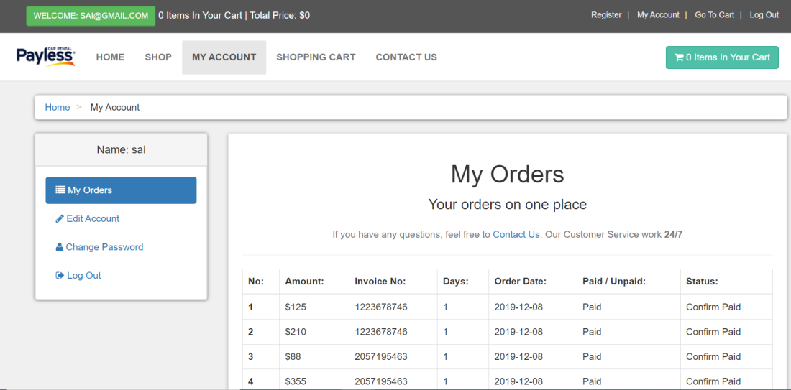

If the user is new and have just logged in, my orders page looks like the one below.

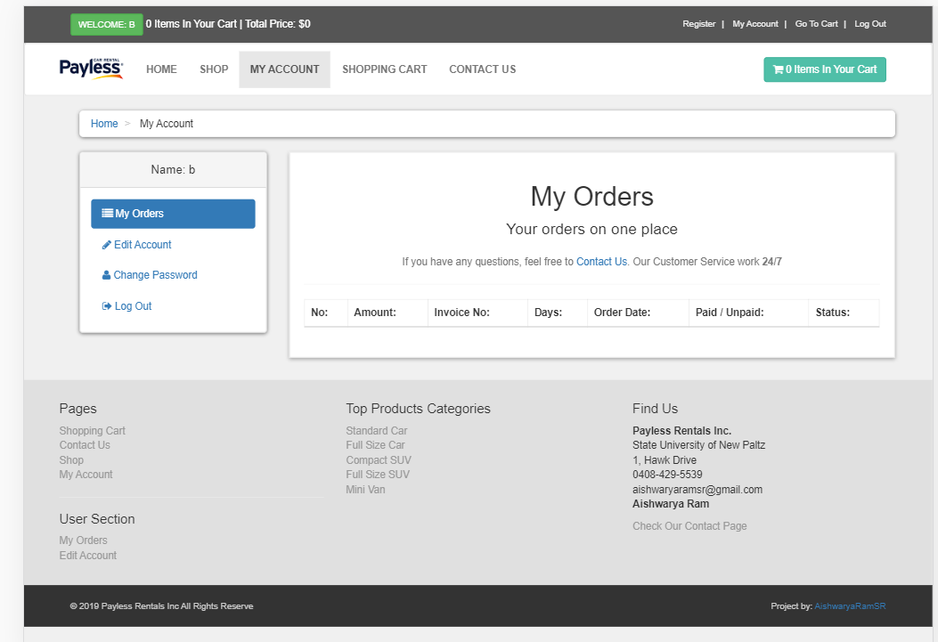

**Go To Cart:**

PHP Code can be found from here: cart.php under “html” folder. See the image below for the directory location.

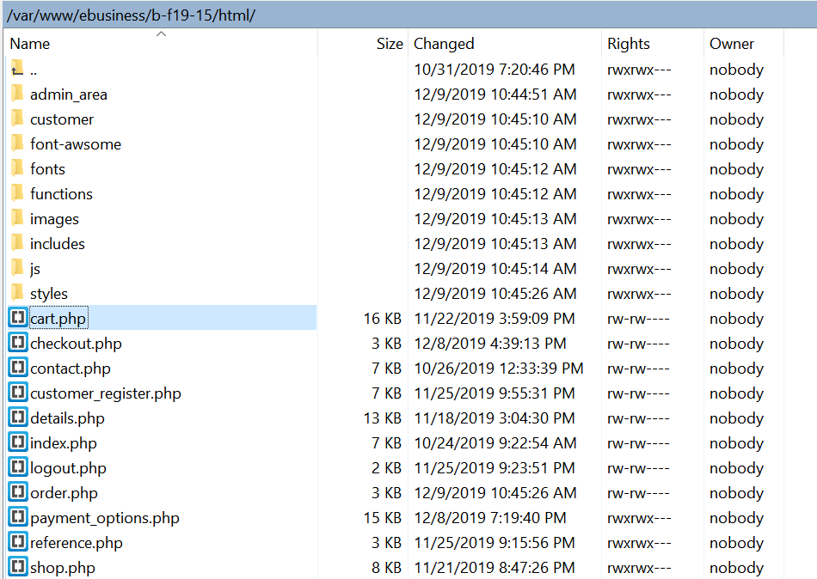

The Shopping Cart looks empty when you have not added any items in your cart.

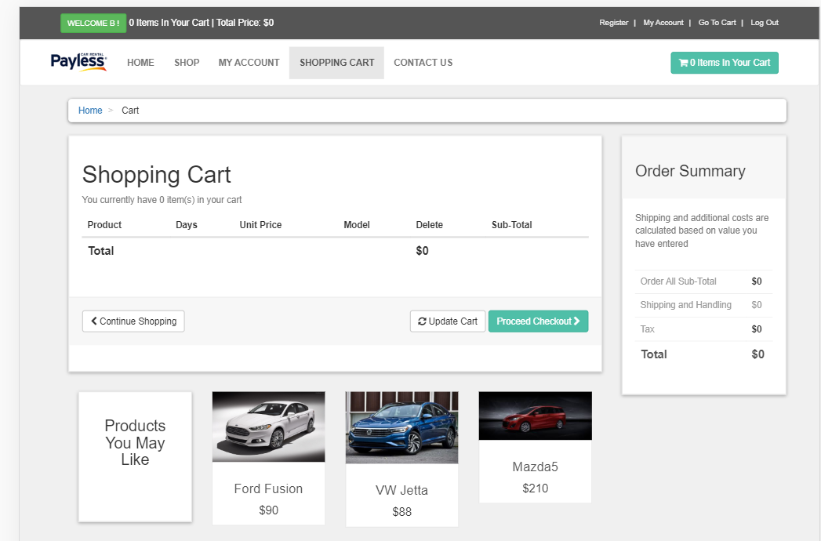

**LogOut:**

PHP Code can be found from here: logout.php under “customer” folder. See the image below for the directory location.

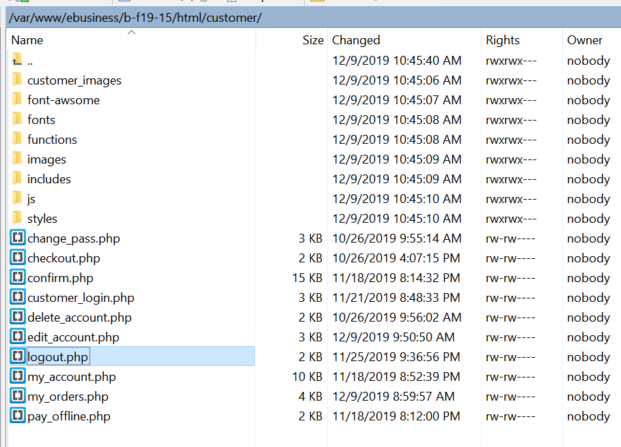

On LogOut, items in your cart gets deleted and all the session ID’s will be destroyed. There is also a pop up message that says “You are logged out. Your Cart is Empty”

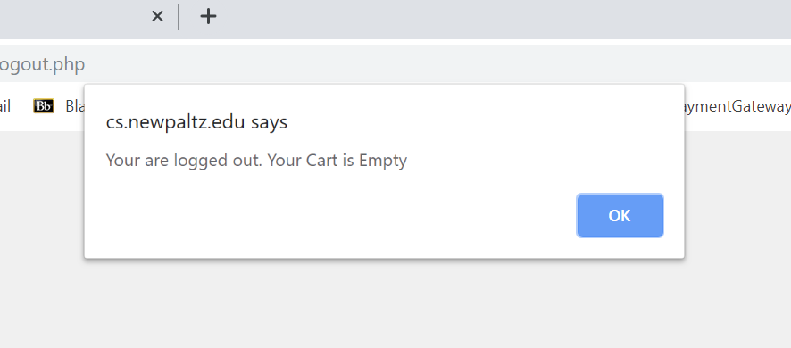

**6.1.b Body**

My Home Page has a slider Image that keeps sliding every 2 seconds using Corousel effect and the images are loaded from the Database and the table name is “slider”.

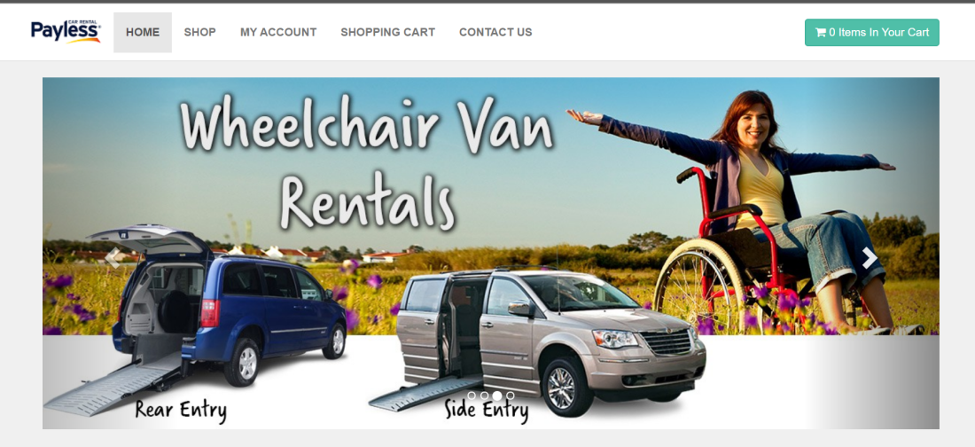

Home Page also lists the various products from our catalog.

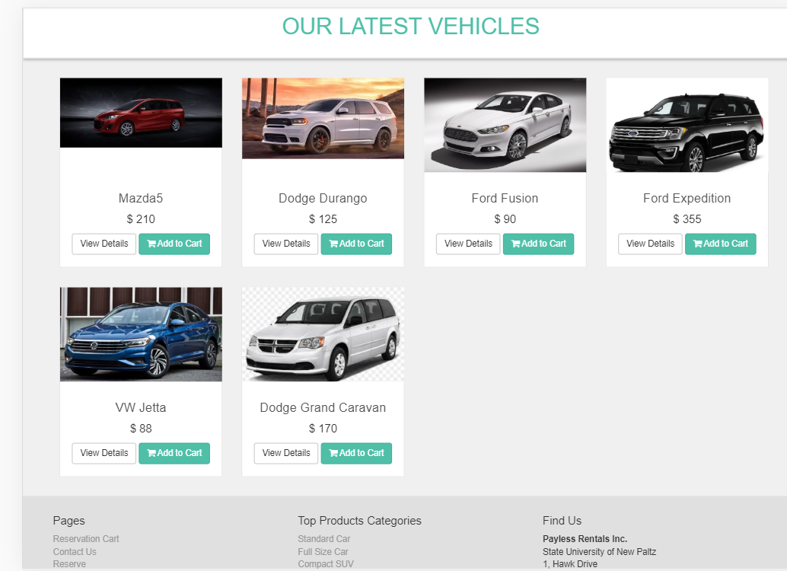

**5.1.c Footer**

Footer also has links to the following pages.

* Cart Page
* Contact Us Page
* Shop Page
* My Account Page
* Login Page
* Registration Page
* Different Categories Page

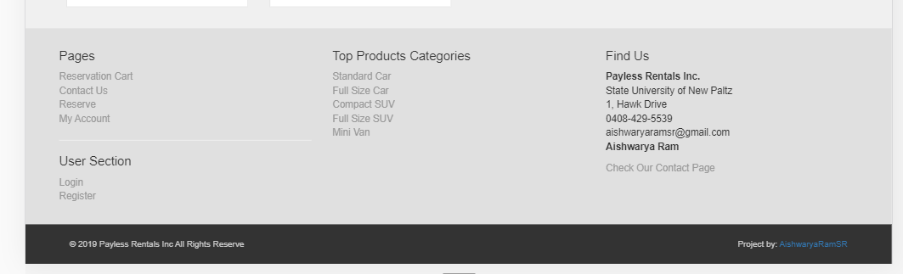

**6. DEMO/Test:**

Let us start with Registration Page first. I am going to use a real name, address and information to test my website, but it can also be tested with just a letter “a” for all fields. For Documentation purpose, I will use full details to store in my database.

Note: Catalog page can be viewed even before logging in. You can also add items to Cart even without logging in, but when you proceed to check out, You will need to log in. If you are not a registered user, you may first want to register before placing an order.

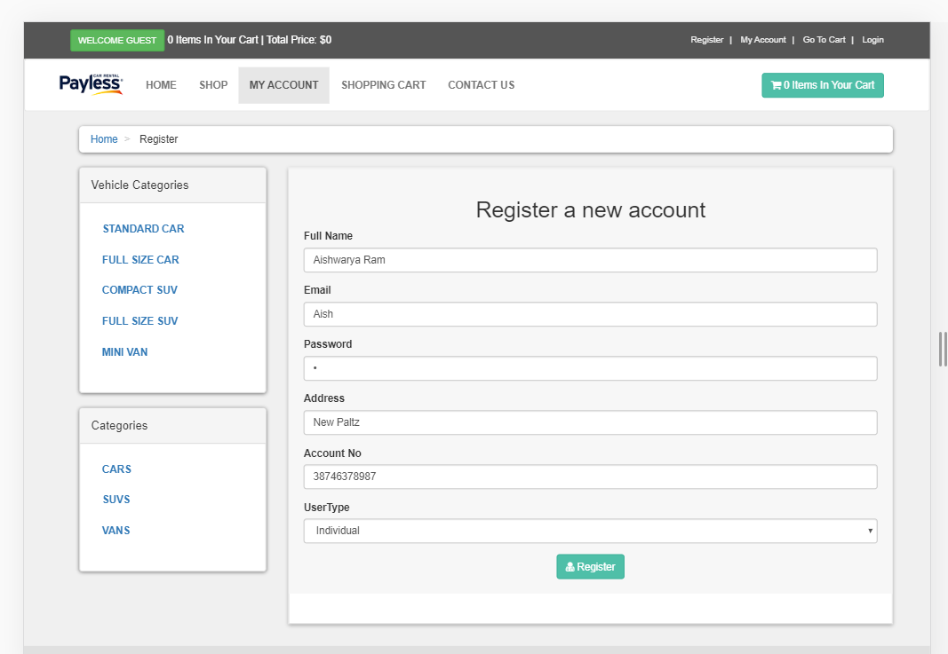

On Successful registration after filling out all the necessary fields in my form, the user will get a message that says “You have been Registered Successfully.” At the same time, customer details gets stored in the customers table.

Customer’s Table before registering,

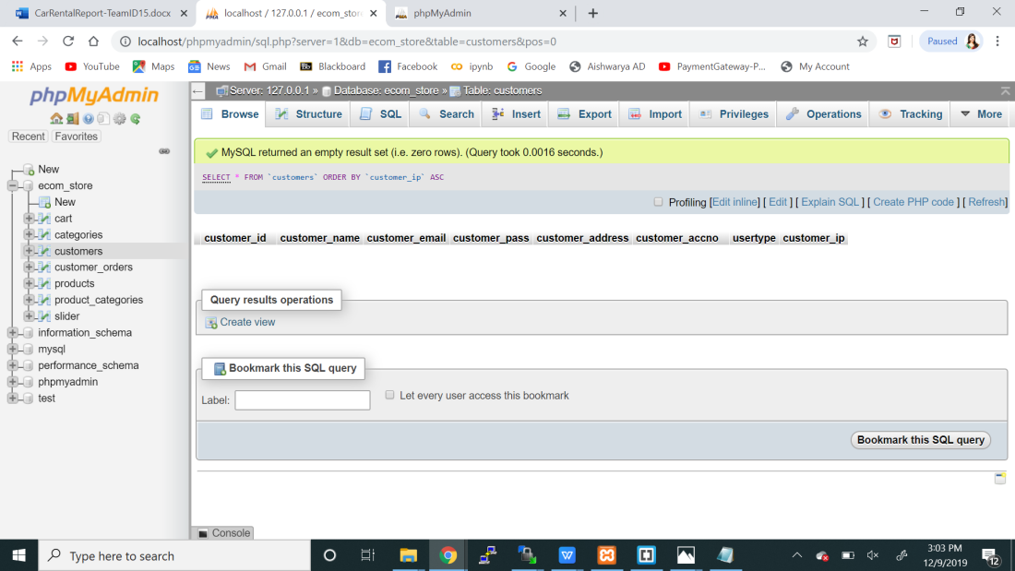

Customer’s Table after registering,

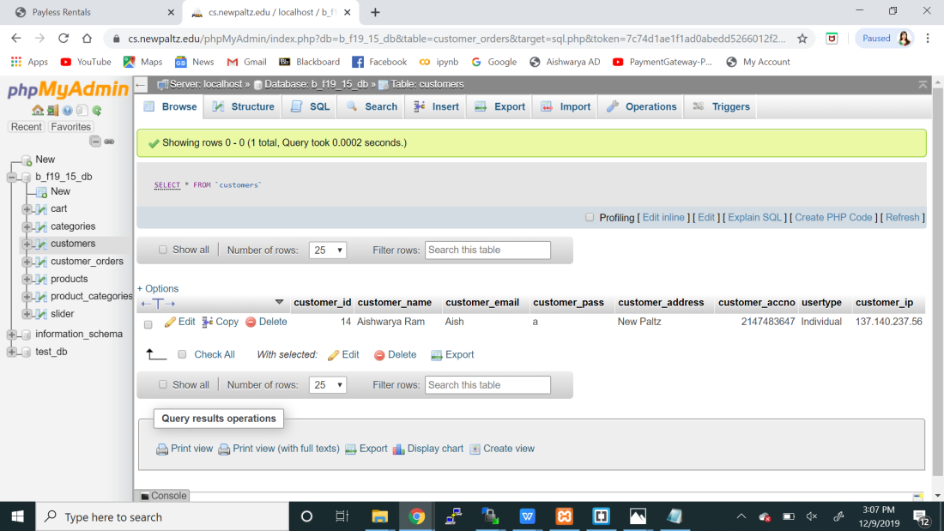

PHP Code for Shop can be found from here: shop.php See below for the directory location

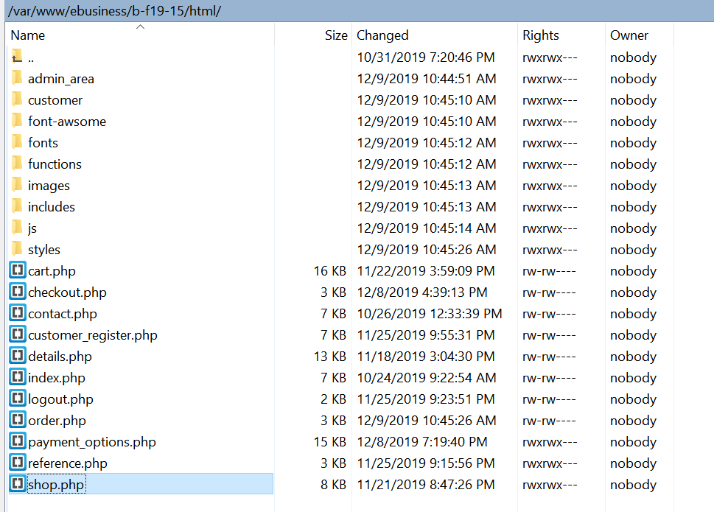

After registration, You can see “Welcome Aish” which is stored in the Session ID variable. You can also see that there are no items in your cart initially.

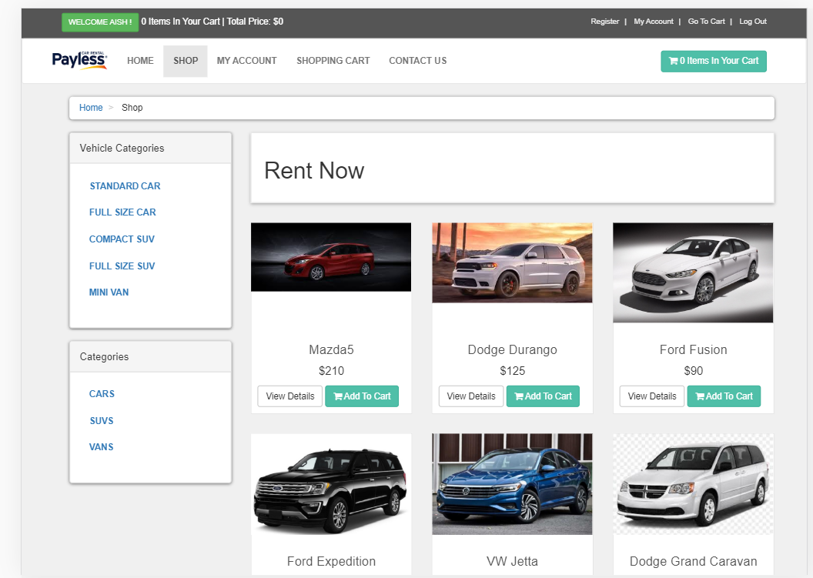

PHP Code for Item Description Page can be found here. Details.php See below for directory location.

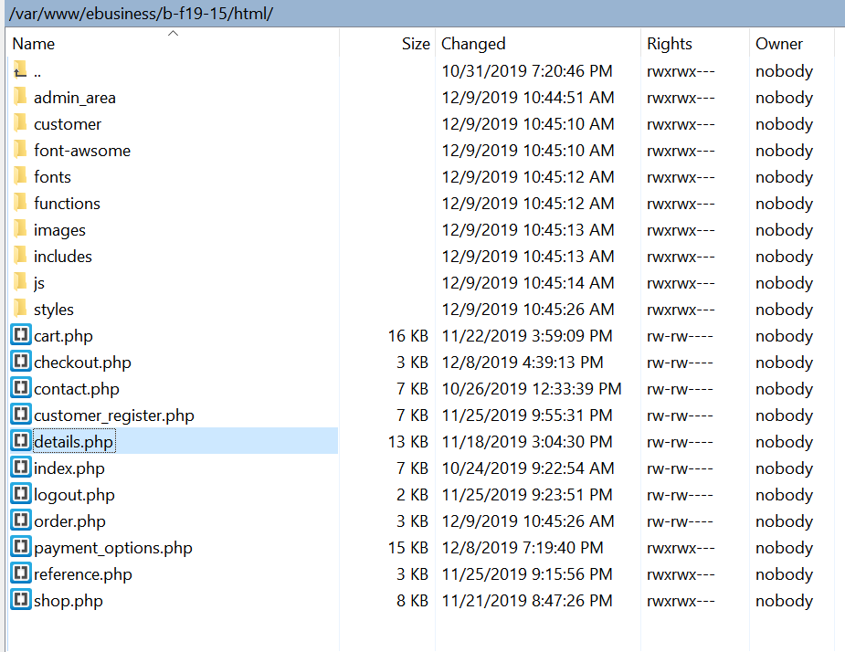

When we click on any of the product, it will take us to the details of the Car page.

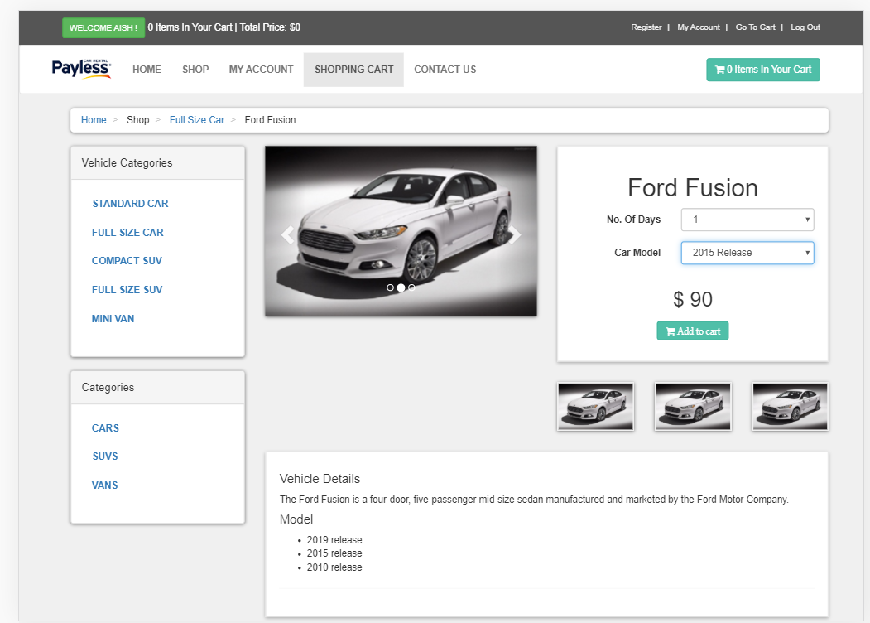

The user can choose the no. of days to rent the car and the model of the car. The Product also has a description at the bottom. When you click on the “Add to Cart”, it will be added to Cart and the number of items in the Cart will get increased based on your request.

Now, let us also add one more item to the Cart by following the same process.

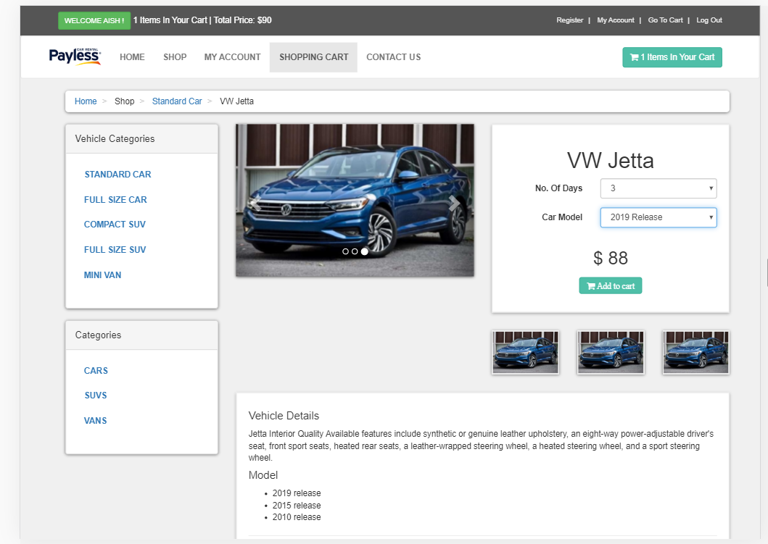

In this item, I have chosen the no. of days to be 3 and the Car Model as “2019 Release”. After adding this item on Cart, the Cart count will be changed from 1 to 2.

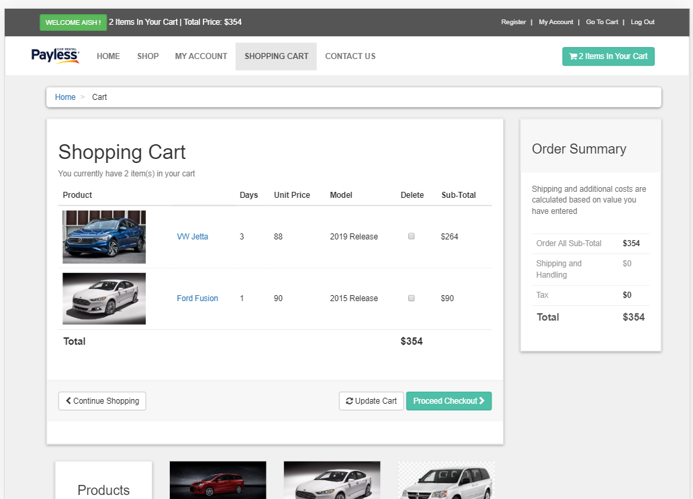

PHP Code for Cart: Cart.php which is also found under “html” folder.

/var/www/ebusiness/b-f19-15/html

On successful addition to Cart, the Cart Table gets filled with these details below,

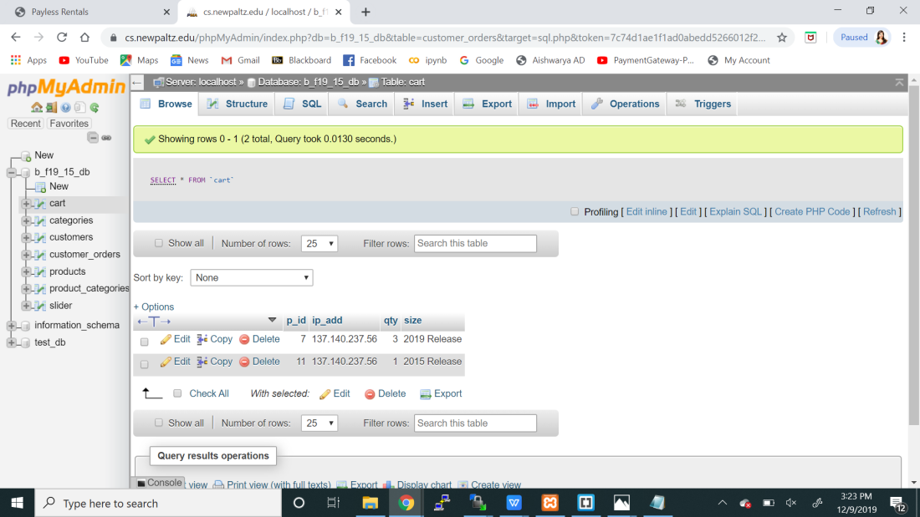

I will now add one more item to the Cart in order to show the delete or update functionality of my Cart Page.

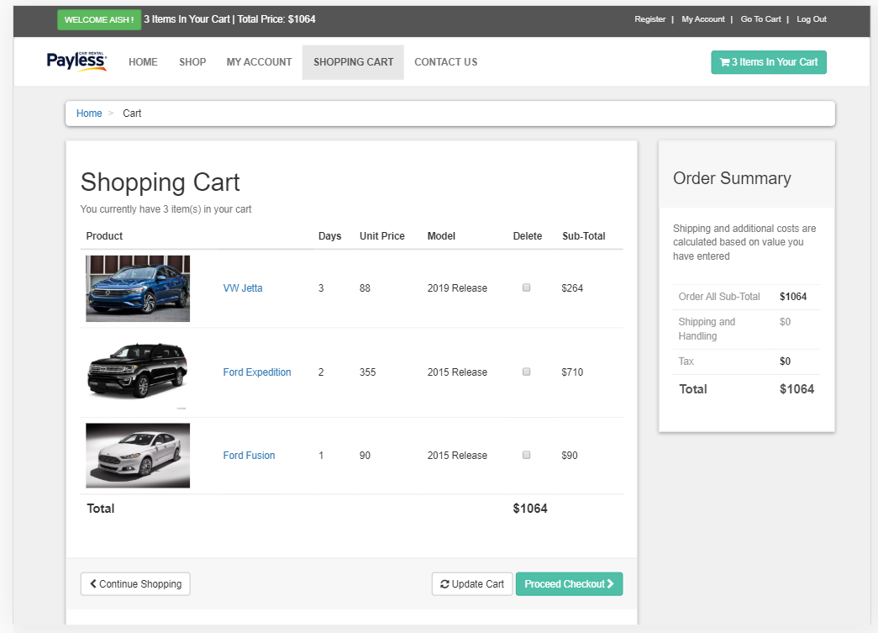

Now, let me delete the VW Jetta from the Cart by checking the box under delete column corresponding to VW Jetta. My Cart Page gets updated and it looks like the one below,

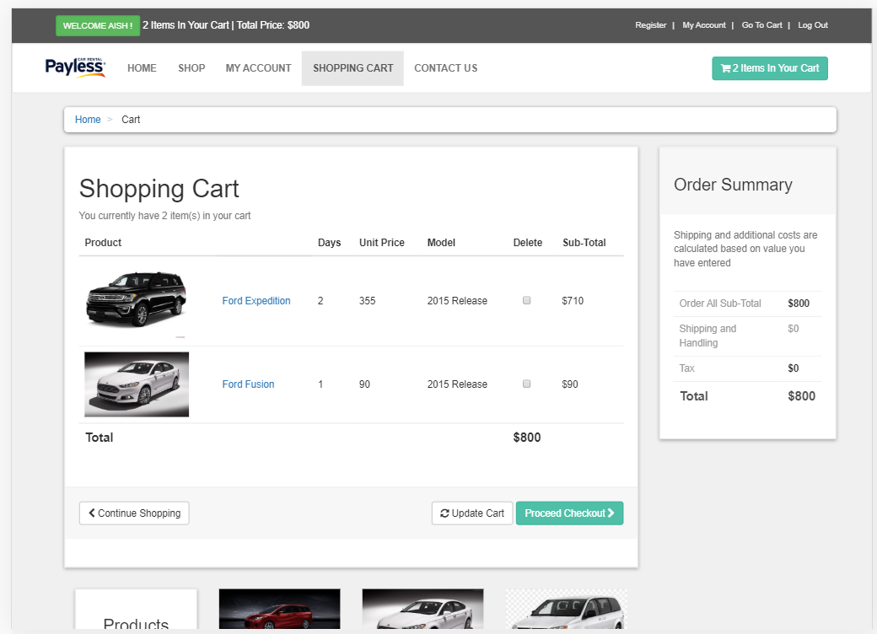

Simultaneously, the Cart Table in the Database also gets updated with the newly added car and deleted car details.

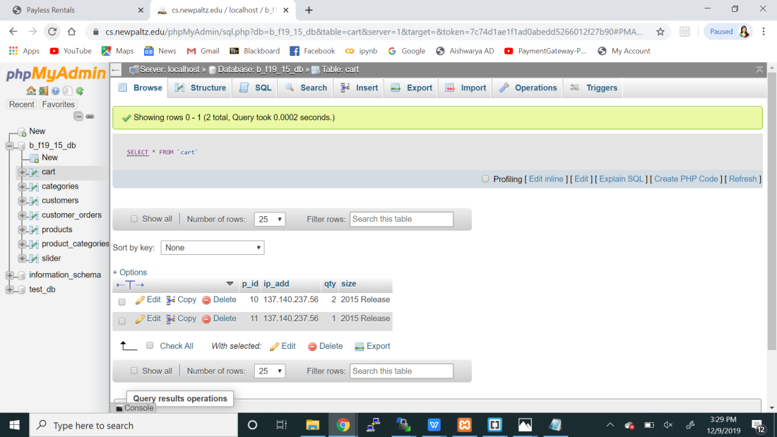

On Clicking the “Proceed Checkout” Button, the page gets redirected to the Check Out Page, which has the information about the Order Summary where Tax amount is calculated and added to the Grand Total, Shipping information where the user has to choose the “Shipping Method” which either could be “Standard Delivery” or “Speed Delivery”, Shipping Address where the User would like to send the item to, Payment information where the user has to enter the Account Number and proceed to “Confirm Payment”.

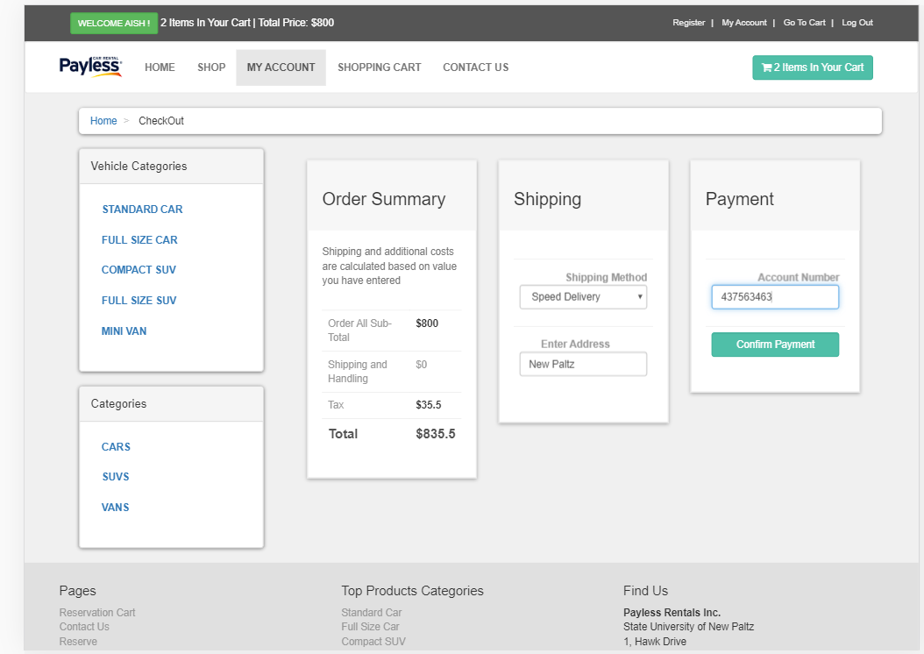

PHP Code for Cart: payment_options.php which is also found under “html” folder.

/var/www/ebusiness/b-f19-15/html

Let us also check the Item Inventory Count for Ford Expedition and Ford Fusion before placing any Order. The current count for Ford Expedition p_instock is 92, p_outstock is 8 and for Ford Fusion p_instock is 96, p_outstock is 4.

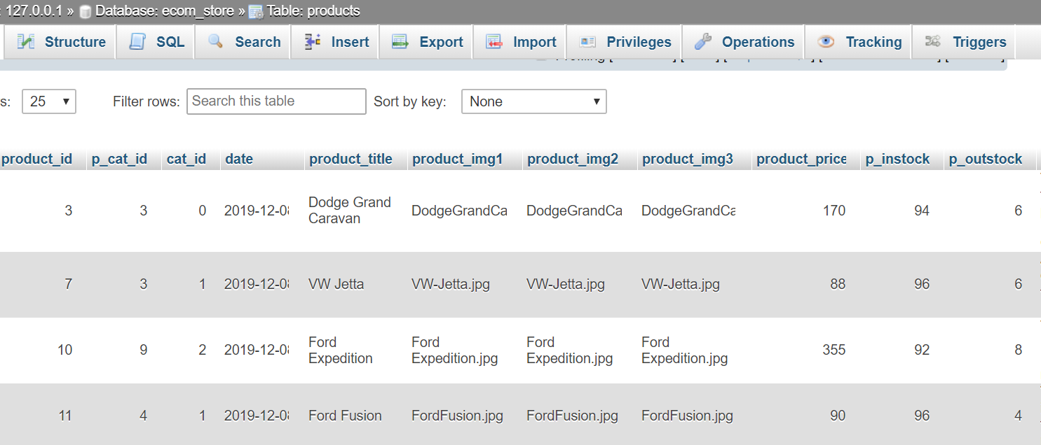

On Clicking the “Confirm Payment” button, You will see a pop up window with the message “Your orders has been submitted and your confirmation number is 914091562”.

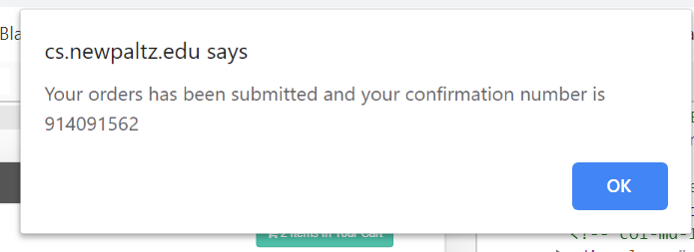

Let us check the “Products” table’s inventory count after placing the order.

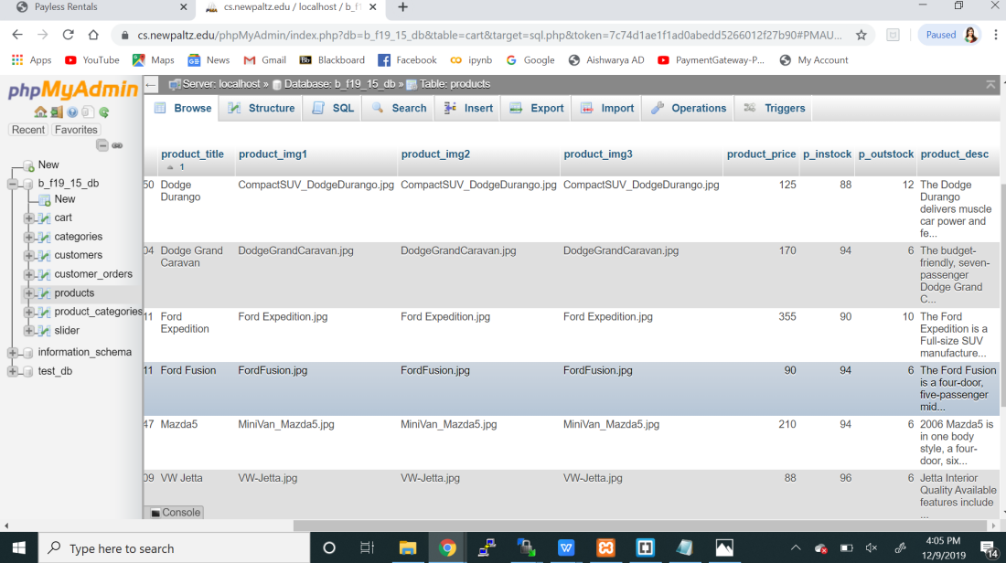

The Inventory Count pf the p_instock for Ford Expedition changed from 92 to 90 and the p_outstock increased from 8 to 10. Similarly, The Inventory Count pf the p_instock for Ford Fusion decreased from 96 to 94 and the p_outstock increased from 4 to 6.

The Customer_Orders Table also gets populated with the order details. Let us see it below.

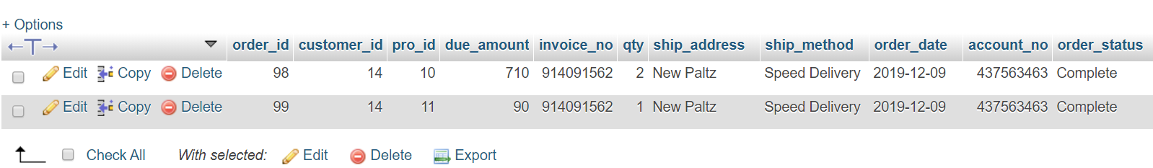

The user also can view his orders form the UI in the My_Orders Page.

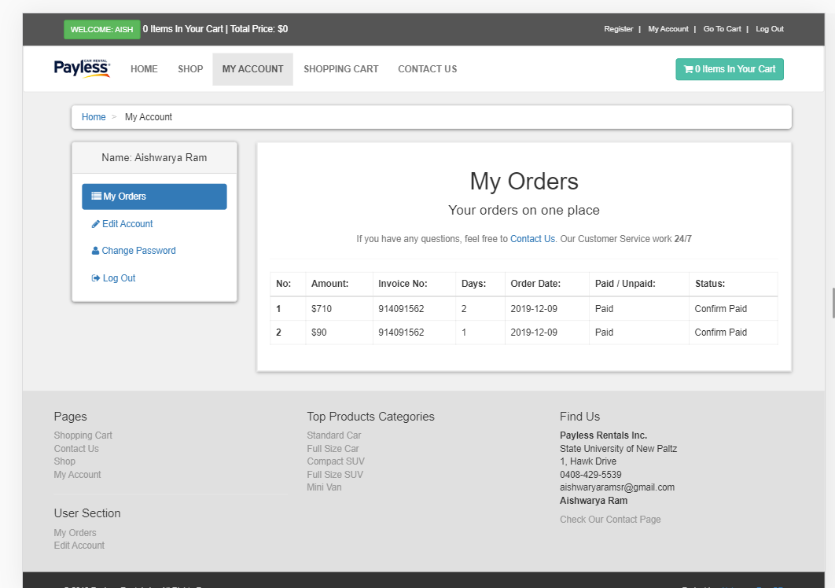

On Successful Order Placement, after the pop up message with the Confirmation Number, Cart items that were stored, will get cleared off.

Other Additional Features include the following,

**Editing your Account:**

**MyAccount- Edit Account**

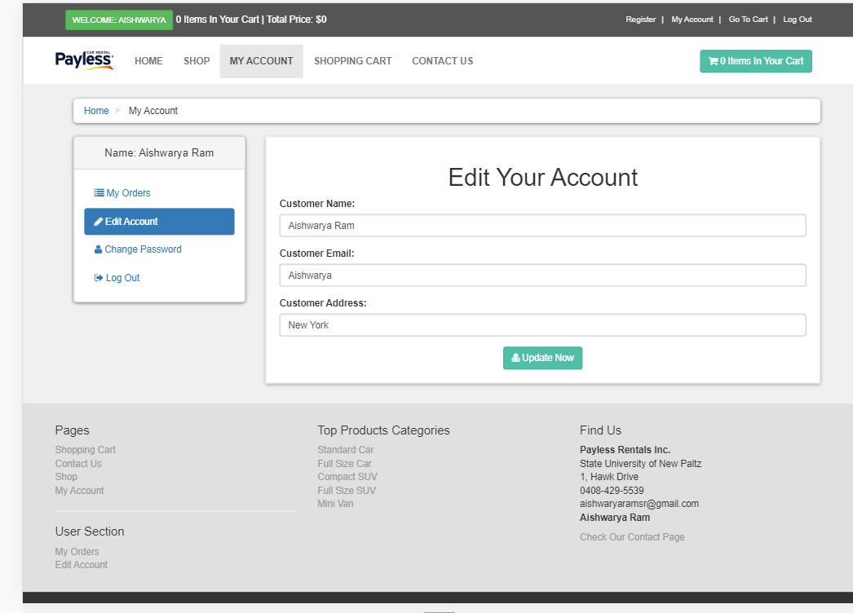

PHP Code for Editing the Account: edit_account.php which is found under “customer” folder.

/var/www/ebusiness/b-f19-15/html/customer

You will get a pop up message like the one below,

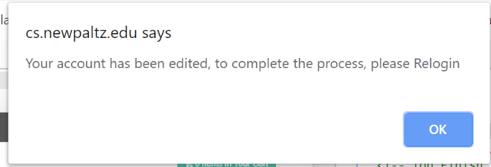

You need to re-login in order to reflect the changes. After logging in, the customers table gets updated.

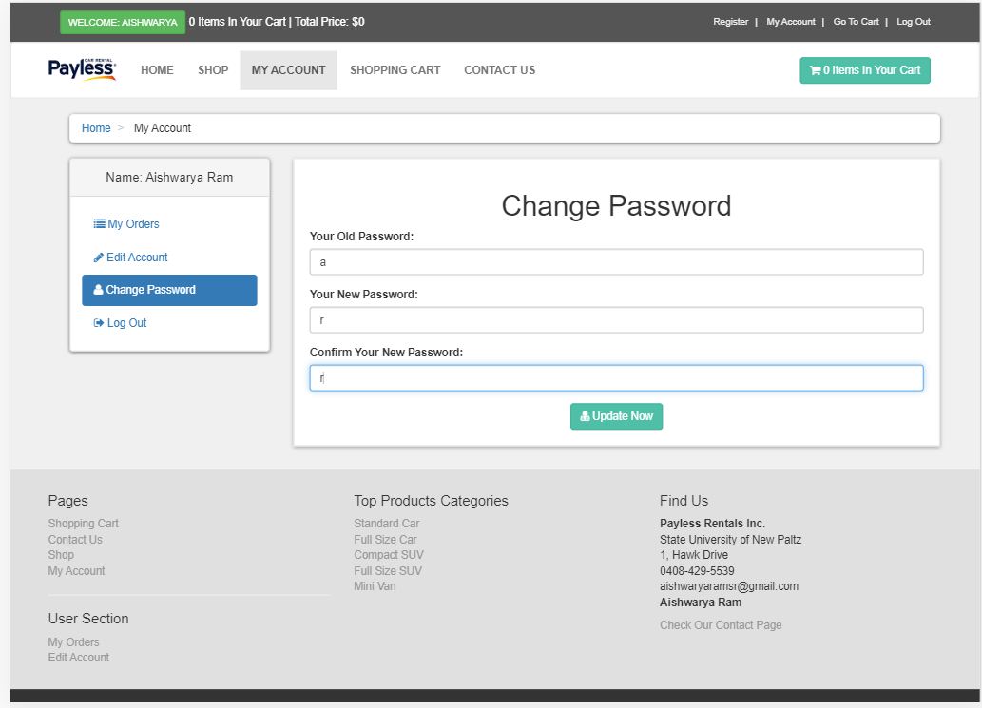

PHP Code for Changing the Password: change_pass.php which is found under “customer” folder.

**/var/www/ebusiness/b-f19-15/html/customer**

A pop up message that indicates that your password has been updated.

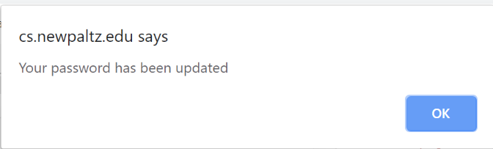

Vehicle Categories on the side bar in the Shop Page will display vehicles based on the Category selection you make. For example. When the Standard Car Category is selected, it displays the vehicles with that category type only.

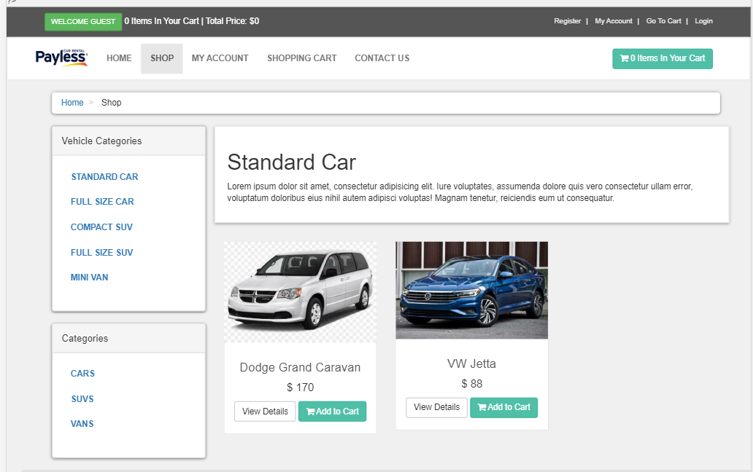

We have only 2 Cars under Standard Car as seen from the picture above.

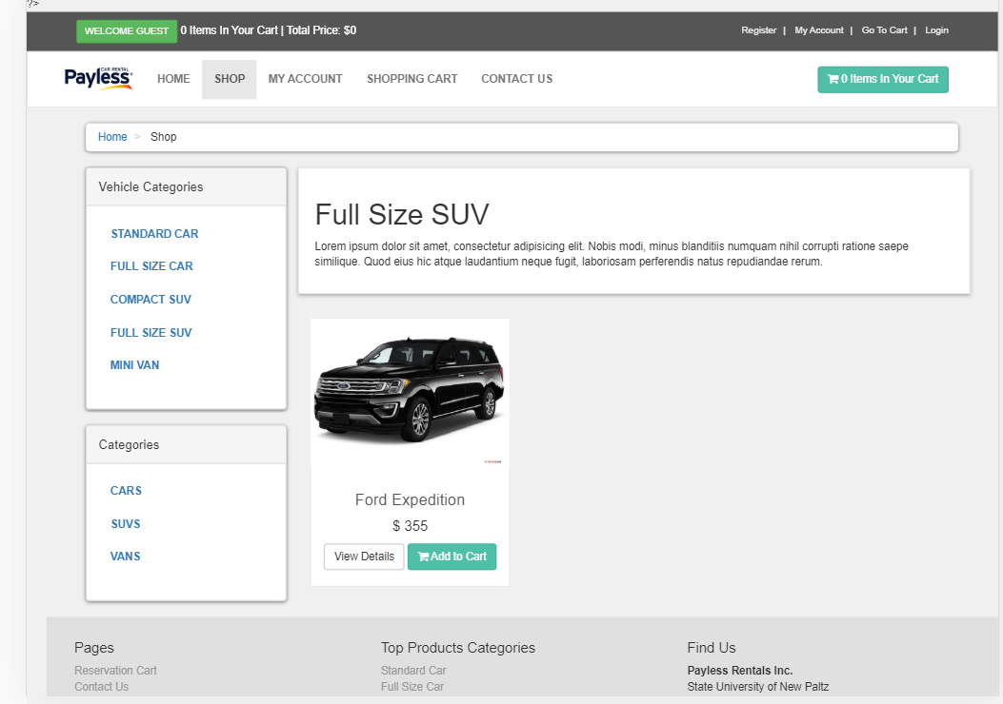

We have only one SUV under Full Size SUV as seen from the picture above.

1. **DEVELOPER’S GUIDE:**

How to run my project?

Please go to this link

<https://cs.newpaltz.edu/e/b-f19-15/>

How to set up my project on CS shared folder? What needs to be changed when my Project is moved to a different folder?

Need to copy all my Project Files under HTML folder to the new server. Change the permission of each file to 0755 in the properties.

For SQL Connectivity, Need to change the sql connection string under the “functions ” folder in functions.php and under “includes” folder in “db.php”

When my website wont work?

When two or more e-city customers attempt to purchase the same product at the same time, it may load for longer time. You can overcome this issue, by trying to place order after say 5 mins. Assuming the other person have stopped using that service.

**For End Users:**

You can add Vehicles to your Cart, but before check out, you have to login first. If you are not registered yet, you may want to register first.

In the Registration Page,

* Full Name, Password, Address can be any length word or a single letter
* Email can be any length word or a single letter with or without gmail.com
* Account Number can be any number of digits

In the Home Page, you can select any Car and it will take you to Details Page of that Car. Then you can add that item to Car by choosing how many days you want to rent the Car.

You can add more items from either Shop Page or Home Page.

You can view all the items added to Cart from Cart Page.

In the Check Out Page, you can choose any Shipping Method in the dropdown box, Enter any address and Account Number can be any length digits and Proceed to “Confirm Payment”

Your order will be placed and you will be provided with a confirmation number on the pop up window.

After that, you will be redirected to your account Page where you can see the history of your orders.



**8. CHALLENGES:**

**Isssue1:**

Initially I had issues with Cart. When a user logs out, his items in Cart did not delete and it was showing to the next user. I fixed that issue, by deleting the items added to cart table in the database by the previous user. Here’s how I did that. When the user logs out, his session ID gets destroyed, Along with that I also added the Delete Query on the Cart table for that IP user.

**Issue2:**

When I tried to add order details to customer_orders table, the record didn’t get inserted. Then I realized that I missed a single quotation in the Insert Query which was a very small thing that was difficult to find.

Instead of ,

$insert_customer_order = "insert into customer_orders (customer_id,pro_id,due_amount,invoice_no,qty,ship_address,ship_method,order_date,account_no,order_status) values ('$customer_id','$pro_id','$sub_total','$invoice_no','$pro_qty','$ship_address','$ship_method',NOW(),'$account_no','$status')";

I had this code,

$insert_customer_order = "insert into customer_orders (customer_id,pro_id,due_amount,invoice_no,qty,ship_address,ship_method,order_date,account_no,order_status) values ('$customer_id',$pro_id','$sub_total','$invoice_no','$pro_qty','$ship_address','$ship_method',NOW(),'$account_no','$status')";

$prod_id has a single quote missing, because of which my record was not inserted.

**Issue 3:**

When copying the files from my localhost to CS Shared Folder, I missed to change the DB connection string. After making changes to functions.php under “functions” folder and db.php under “includes” folder, I was then able to make successful connection to the Database.

**Corrections Implemented After Review by Professor Hanh Pham:**

1. Registration had too many fields like Profile Picture, Contact Number, Customer City and Country. I removed all of these and had only limited fields.
2. Implemented Session ID for Cart Items Count and destroyed the Session ID’s on log out.
3. Added Shipping details to my website at the later stage with minimum field such as Shipping method and Shipping address; Payment information had only Account Number in it.
4. On Successful order placement, Order Confirmation Number was generated and shown to the customer for their reference.
5. Implemented Inventory Count of instock and outstock for each of the Products. When an order was attempted to make on a product that had inventory count less than 0, then the user will be informed the product is “Out of Stock. You cannot place your order.”
6. “Delete Account” is a functionality that deletes the customer record from the registered users table. Removed this functionality after the review from the Professor.

**9. CONCLUSION:**

E-Business Course has taught me the Core basics of Web Programming both Client side and Server Side. In this project, I was able to write a hand coded HTML program with CSS styling, PHP as an Interface. I learned to write a server program using PHP and connect to the database to fetch the records.

I was able to execute insert, update and delete queries and see the result getting updated. Back and forth request and response to the server and the client has given me the confidence to implement any medium level code in Web Programming.

While fixing the many errors that I came across, I understood why those errors were occurring after practise. Between the time I took to fix an issue for the first time versus the time I took towards the end, is the learning experience I gained after doing this Project.

**10.REFERENCES/APPENDIXES:**

Socket Connection and Sample E-Commerce Website -<http://cs.newpaltz.edu/~phamh/aeb/t/>

and <http://cs.newpaltz.edu/~phamh/basics/>

Login form - <https://www.geeksforgeeks.org/html-responsive-modal-login-form/>

National Car Rental Website - https://www.googleadservices.com/pagead/aclk?sa=L&ai=DChcSEwjzu5up4LDmAhUUpLMKHQFkBs0YABAAGgJxbg&ohost=www.google.com&cid=CAESQOD2hNXMuNnm6Sjt5qQUamEHipCenlz4fAzL98IiPQBLz0n2p9dquZ0Dh4QRasvX4fz_MXOHZ5eODBEDvdfCLYg&sig=AOD64_10dl0rWMwWBcdpvZ9MnoHfrnyaHA&q=&ved=2ahUKEwjImJCp4LDmAhXpQd8KHdH6CXcQ0Qx6BAgOEAE&adurl=

Project Notes:



My Website is a Hand-Coded E-Commerce Website which I developed from scratch. I may have seen sample rental website and their templates online to get an idea for my design and look. I have used Geeks for Geeks and W3Schools to learn the basics of the form Implementation and Responsive Design of my Pages.